Ch 10

P/E=Price/Earnings per share



CH 11

 



* Geometric Return = [(1+R1)(1+R2)(1+Rt)]1/t -1



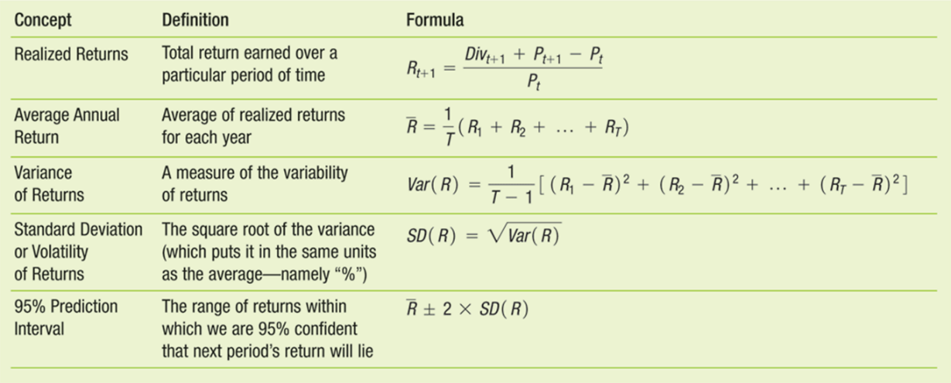

Ch 12

* 
* Portfolio variance = ω12σ12 + ω 22σ22 + 2 ω 1 ω 2ρ12σ1σ2



* ρ12 = σ12/(σ1σ2)

Ch 13

WACC=WdRd(1-t)+WpRp+WERE

`V=D+P+E. WD=D/V. Wp=P/V. WE=E/V

* WACC Equation

*rwacc*=*rEE*%+*rpfd* *P*%+*rD*(1−*TC*)*D*%

For a company that does not have preferred stock, the WACC condenses to: *rwacc* = *rEE*% + *rD*(1 − *TC*)*D*%